**Before Debugging :**

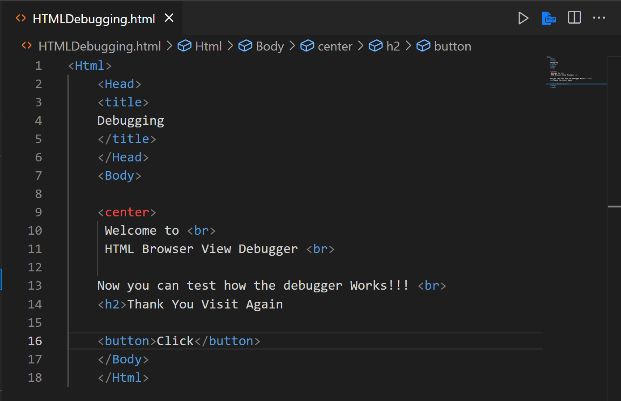

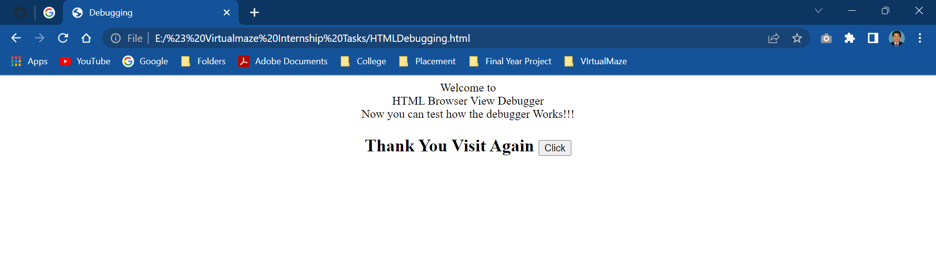

**After Debugging :**

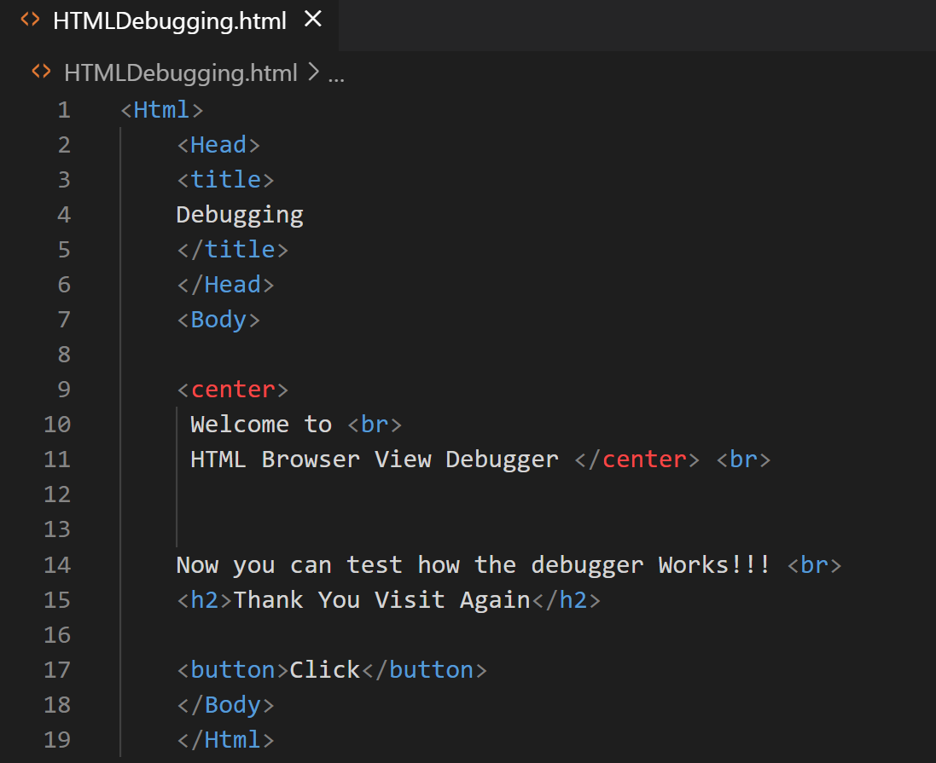

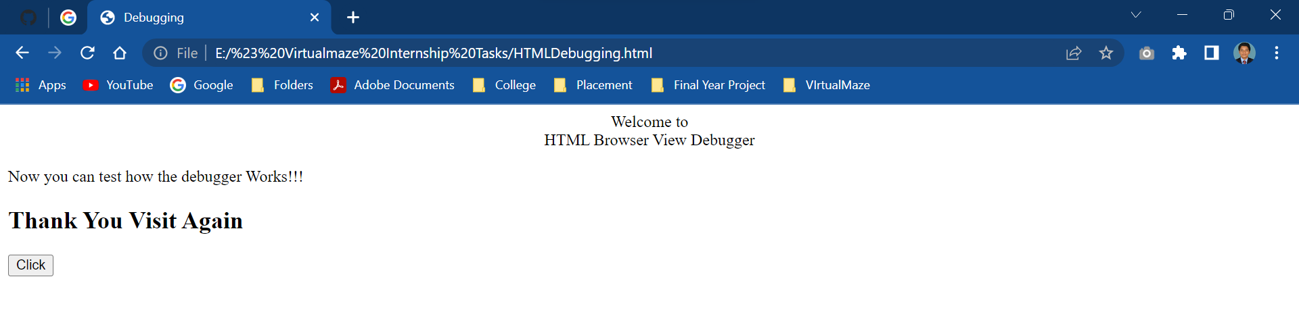

**Inspect :**

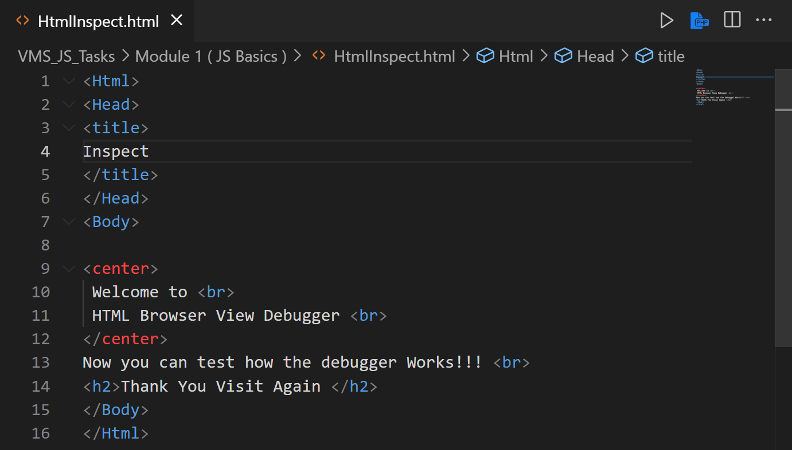

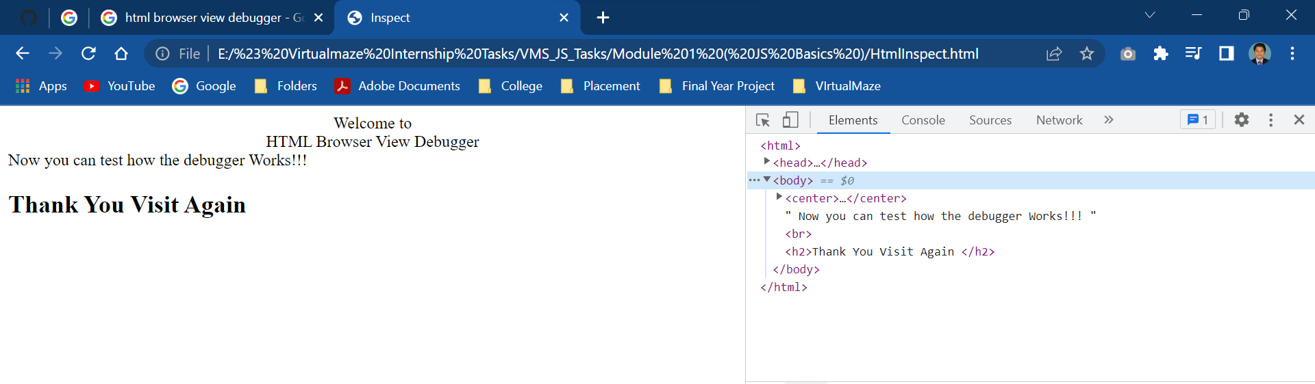

In Inspect after Changing H1 tag it shows the result. But it does not reflect the original Source Code.

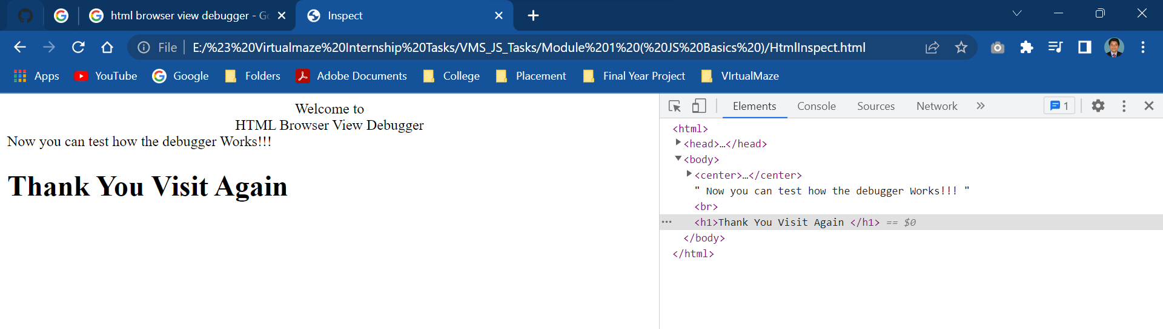

**Responsive View :**

Responsive View using HTML and CSS to automatically resize a website, to make on all devices ( Desktop , Phone & Tablet ).

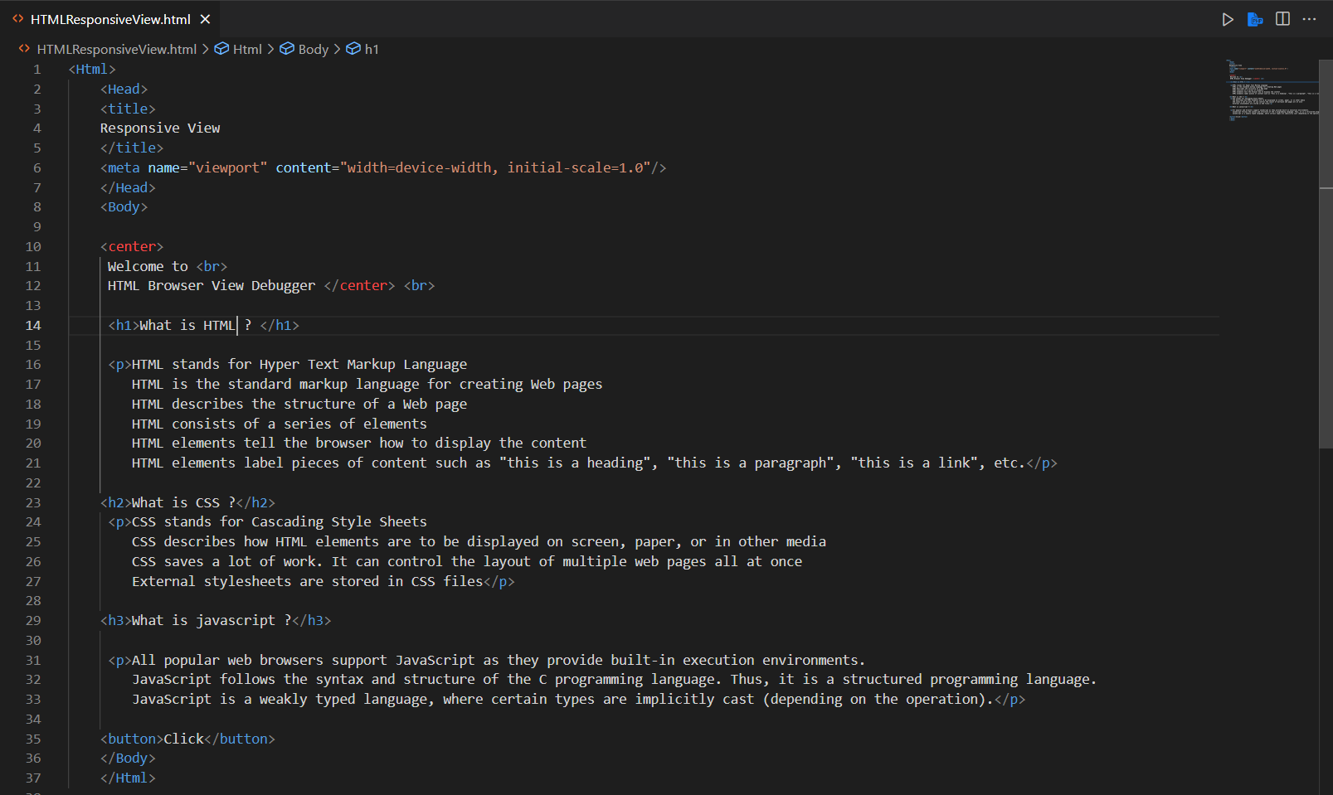

Desktop View :

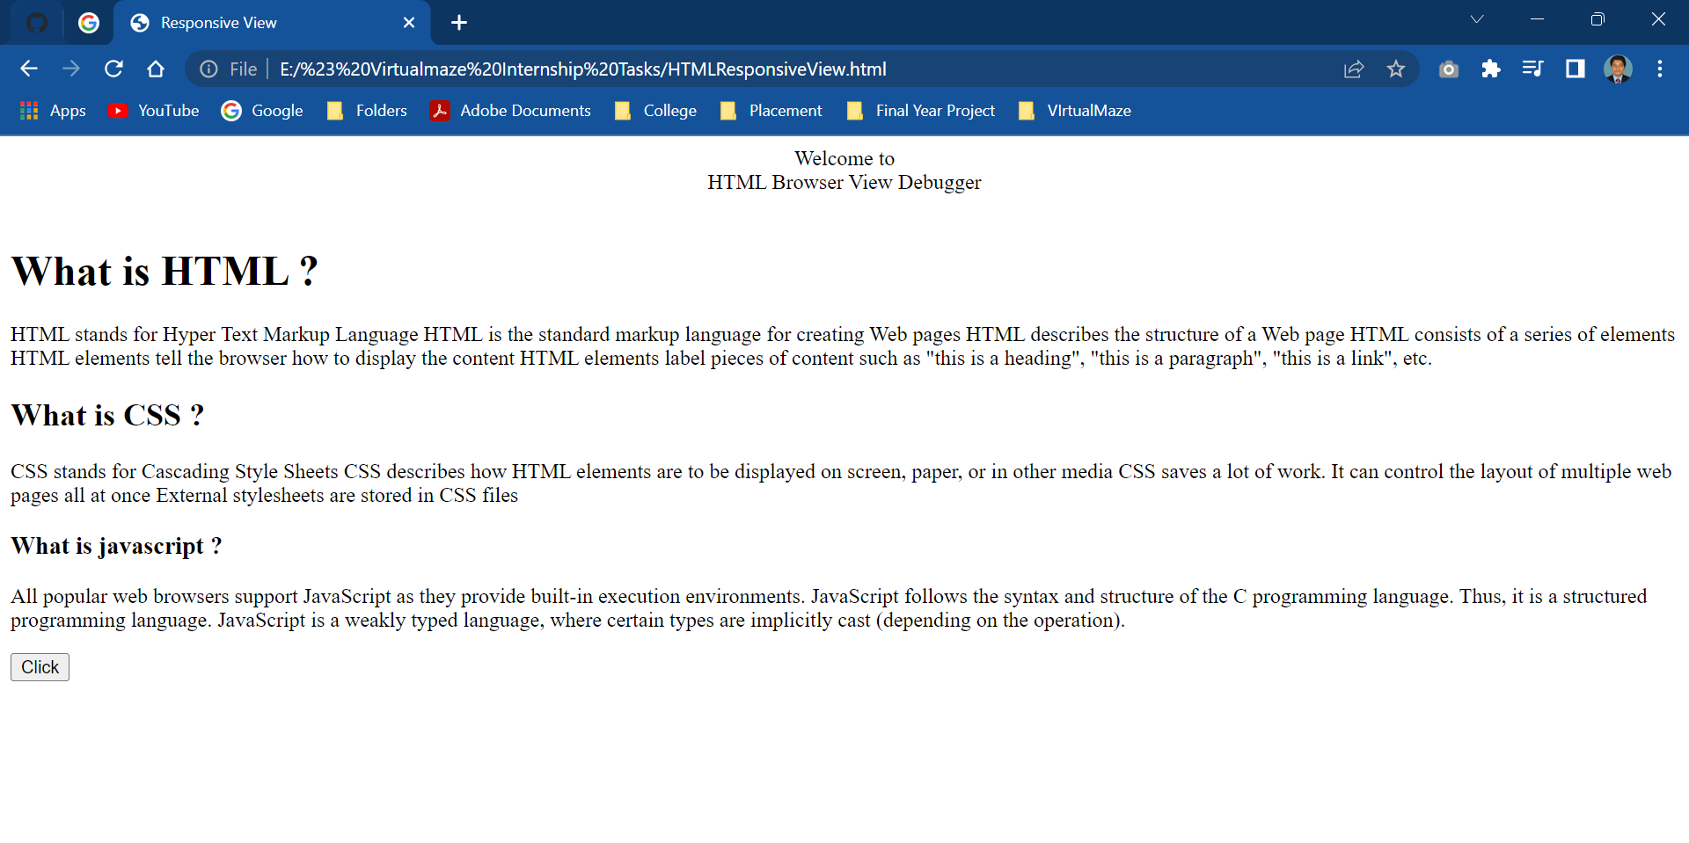

Tablet View :

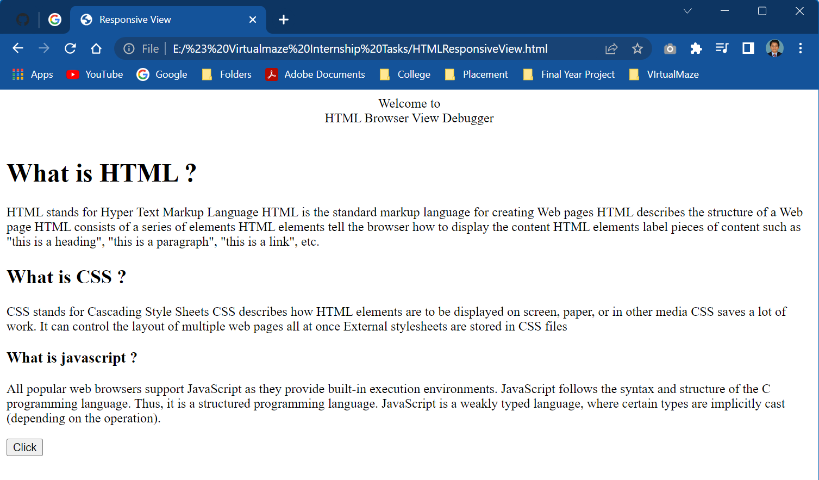

**Mobile View :**

